**Name: Reem Mohamed salama sayed salama**

**B.N: 360**

**Date: 29/5/2020**

**Topic:** **Database Systems**

**Github link:**

**Github page:**

**Application brief:**

## A Database Management System (DBMS) is a system (software) that provides an interface to database for information storage and retrieval. We are more interested in software systems rather than manual systems because they can do the job more efficiently. Characteristics of Database Management System:

* Provides security and removes redundancy
* Self-describing nature of a database system
* Insulation between programs and data abstraction
* Support of multiple views of the data
* Sharing of data and multiuser transaction processing
* DBMS allows entities and relations among them to form tables.
* It follows the ACID concept (Atomicity, Consistency, Isolation, and Durability).
* DBMS supports multi-user environment that allows users to access and manipulate data in parallel.

**Some applications**:

* **telecom**: There is a database to keeps track of the information regarding calls made, network usage, customer details etc. Without the database systems it is hard to maintain that huge amount of data that keeps updating every millisecond.
* **Industry**: Where it is a manufacturing unit, warehouse or distribution center, each one needs a database to keep the records of ins and outs. For example, distribution center should keep a track of the product units that supplied into the center as well as the products that got delivered out from the distribution center on each day; this is where DBMS comes into picture.
* **Banking System**: For storing customer info, tracking day to day credit and debit transactions, generating bank statements etc. All this work has been done with the help of Database management systems.

**Screenshots:**

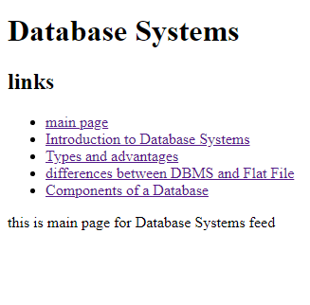

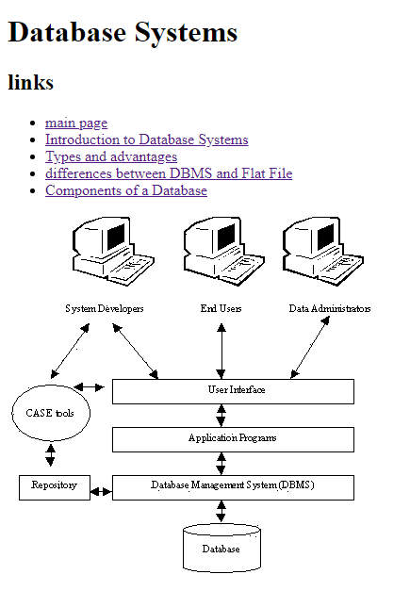

**Source code:**

